# CS 310 Changelog

Name: Matthew Rix

## Version 9.0.0 2023-03-20

Note: Tutorial Ten – Stashing changes in EGits

Major Changes:

* Stashed a stash with @since 1.0 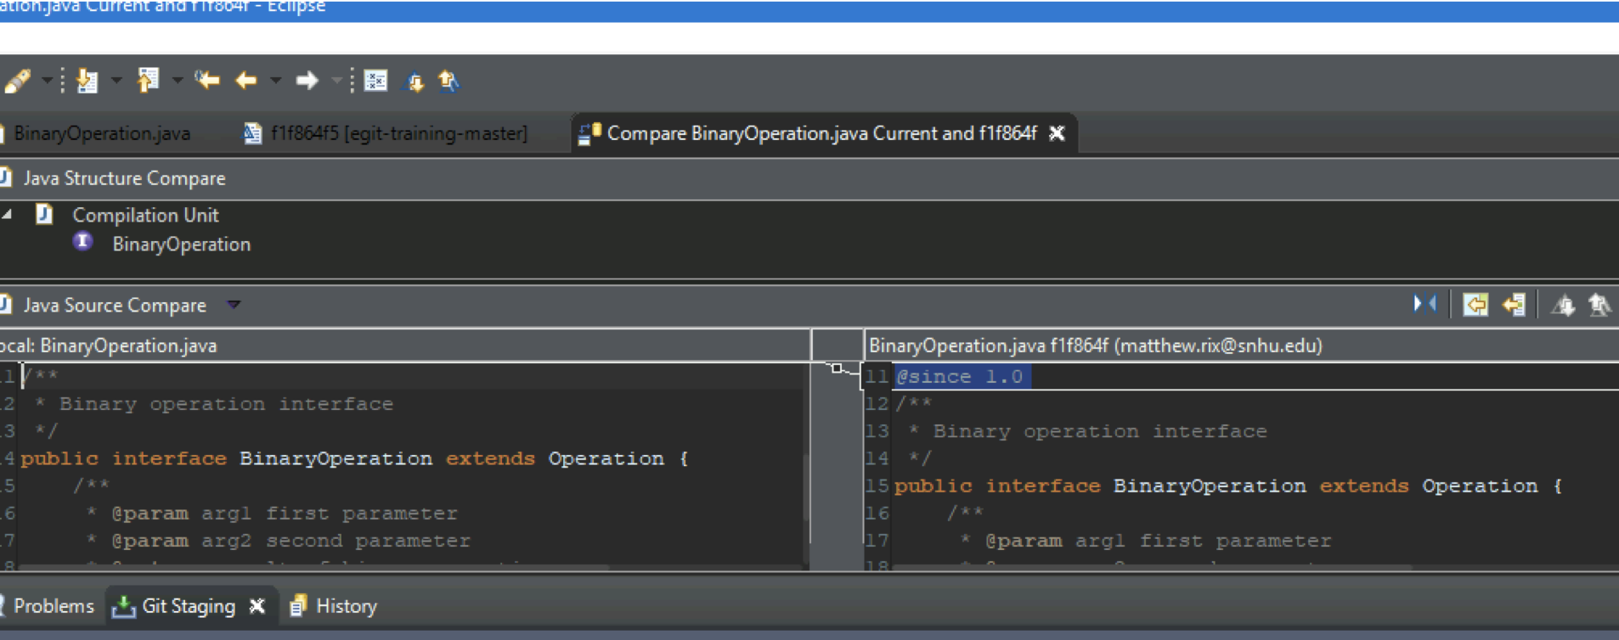
* Created new Javadoc branch from origin/master Graphical user interface, text, application, chat or text message

  Description automatically generated

Minor Changes:

* Applied stash changes to Javadoc branch Graphical user interface, text, application

  Description automatically generated

Bug Fixes:

N/A

## Version 8.0.0 2023-03-20

Note: Tutorial Nine – Use Git blame feature

Major Changes:

* Reviewed revisions in the Calculator.java file Graphical user interface, text, application

  Description automatically generated

Minor Changes:

* Reviewed revisions through history tab as well in the add-divide-functionality branch. Text

  Description automatically generated

Bug Fixes:

N/A

## Version 7.0.0 2023-03-20

Note: Tutorial Eight – Change a series of commits

Major Changes:

* Created add-modulo-functionality-corrected branch off add-multiply-functionality branch and added modulo class 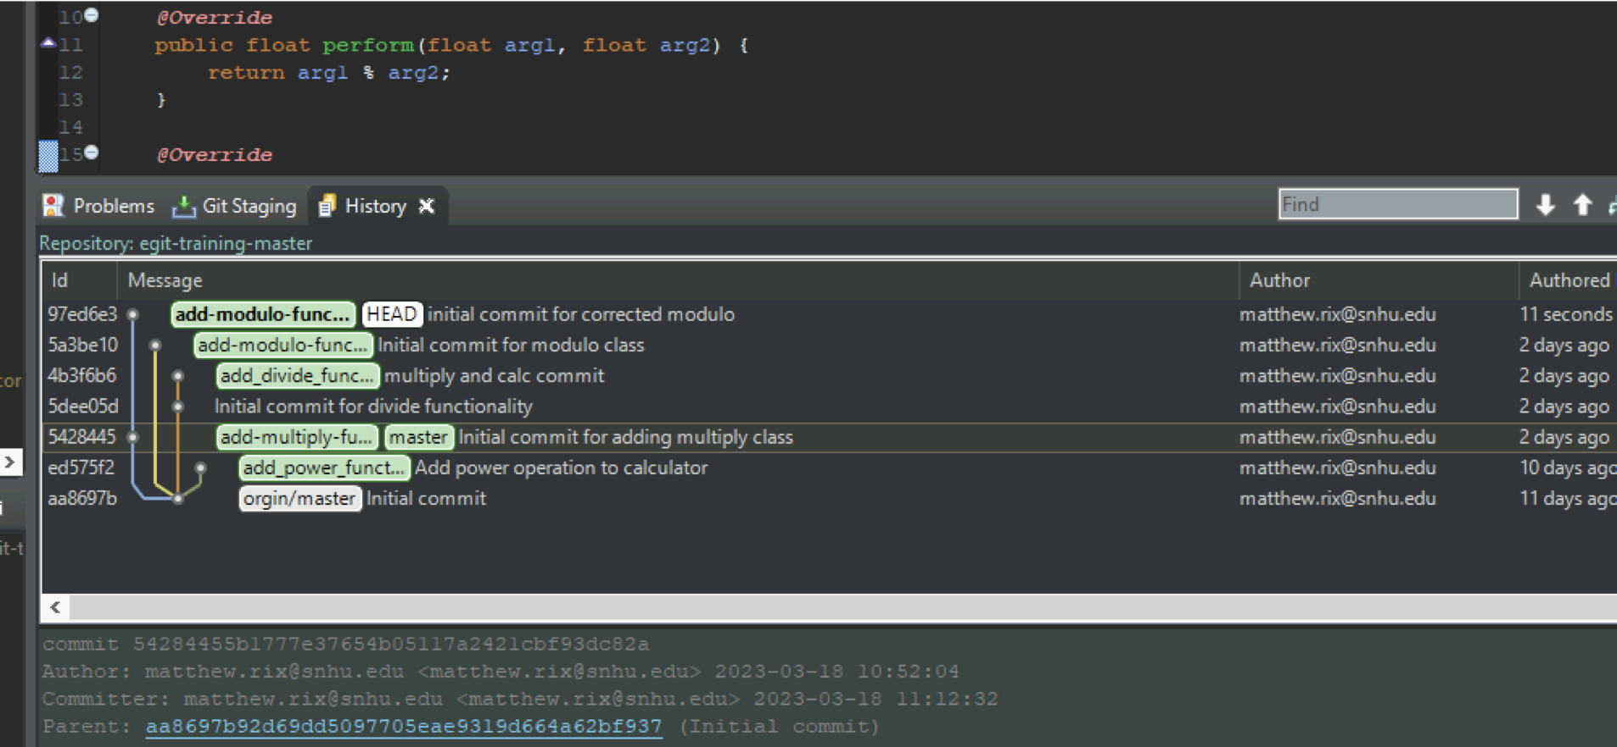

Minor Changes:

* Cherry picked previous add-modulo-functionality branch to new add-modulo-functionality-corrected branch.

Bug Fixes:

* N/A

## Version 6.0.0 2023-03-18

Note: Tutorial Seven – Reset branch to previous state

Major Changes:

* Created add-modulo-functionality branch off origin/master and added modulo class and functionality in separate commits 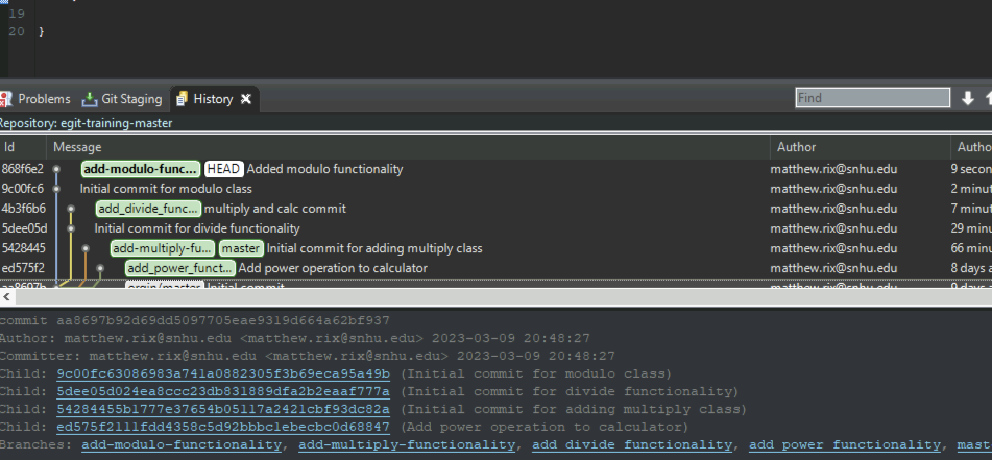

Minor Changes:

* Reset and amended the two separate initial modulo commits Graphical user interface, text, application

  Description automatically generated

Bug Fixes:

* N/A

## Version 5.0.0 2023-03-18

Note: Tutorial Six – Merge, Rebase, and Resolving Conflicts

Major Changes:

* Merged add-multiply-functionality branch with master Text

  Description automatically generated
* Merged add-divide-functionality but had conflicting code Graphical user interface, text, application

  Description automatically generated
* Resolved the conflicts 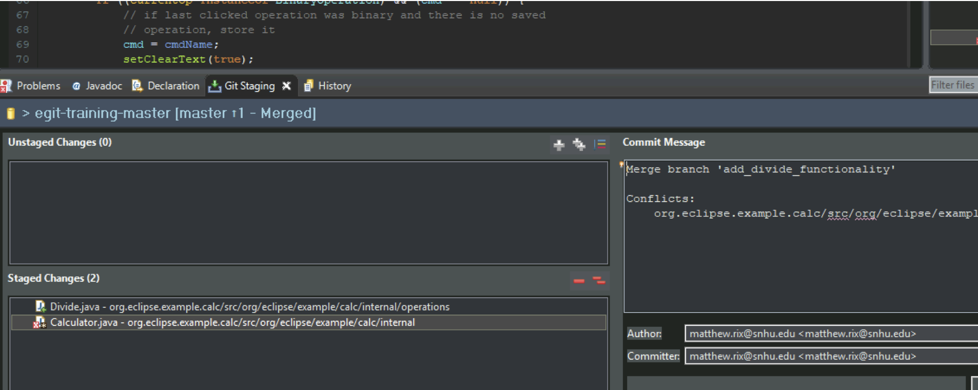

Minor Changes:

* Performed a hard reset add-divide-functionality 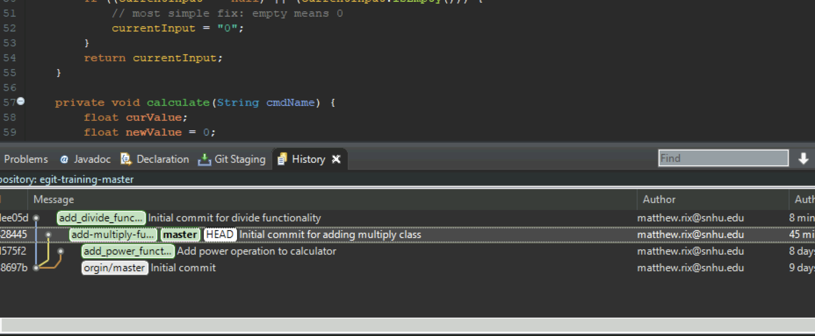
* Rebased add-divide-functionality with master A screenshot of a computer

  Description automatically generated with medium confidence
* Rverted rebase

Bug Fixes:

* N/A

NOTE: Tutorial Five – Fetch latest completed.

## Version 4.0.0 2023-03-18

Note: Tutorial Four – Work on branches in parallel

Major Changes:

* Added new branchGraphical user interface, application

  Description automatically generated
* Created new multiply Class Graphical user interface, text

  Description automatically generated

Minor Changes:

* Made a preliminary commit for the multiply class 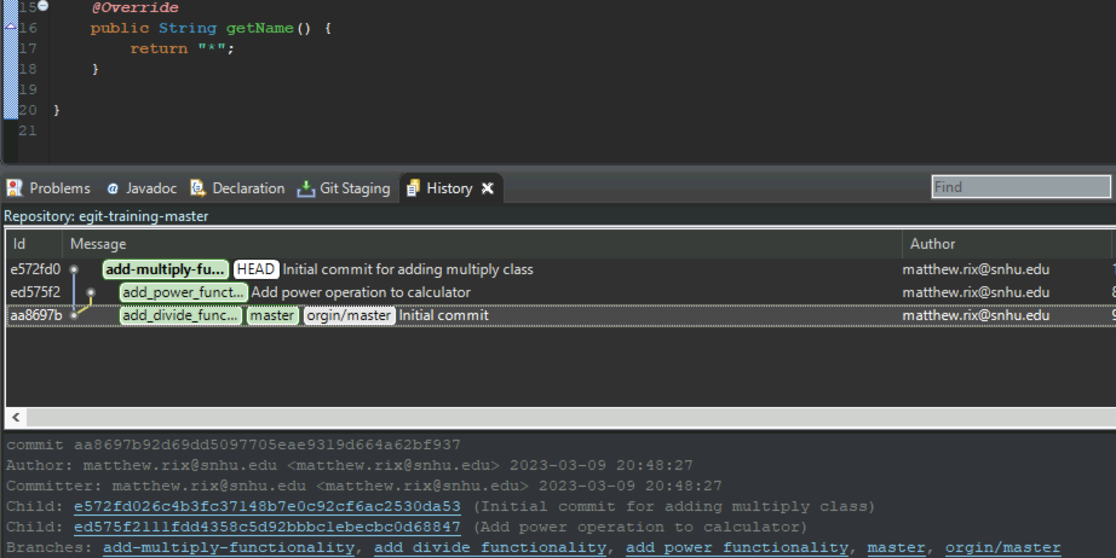
* Amended the multiply commit and pushed to bitbucket repo
* 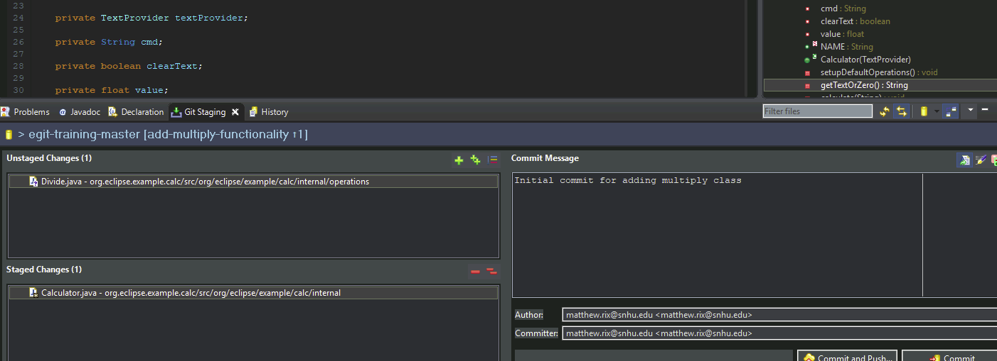

Bug Fixes:

* N/A

## Version 3.0.0 2023-03-09

Note: Tutorial Three – Inspecting the History

Major Changes:

* Configured change history.
  + Graphical user interface, text

    Description automatically generated
* Compared changes in Calculator.java.
  + Graphical user interface, text

    Description automatically generated

Minor Changes:

* Which commits have been done to package org.eclipse.example.calc.internal?
  + commits ed575f2 and aa8697b:
* Pick a commit ID and search for it. Which files have been touched in this commit? What were the changes?
  + ed575f2:
    - org.eclipse.example.calc/srcorg/eclipse/example/calc/internal/Calculator.java
      * Changed the imports and added Power function.
    - org.eclipse.example.calc/srcorg/eclipse/example/calc/internal/operations/Power.java
      * Added File (Initial commit)
* Which commits have changes toCalculator.java.
  + commits ed575f2 and aa8697b.

Bug Fixes:

* N/A

## Version 2.0.0 2023-03-09

Note: Tutorial Two – Develop Another Feature and Use Staging View

Major Changes:

* Created new branch in the Bitbucket repo:
  + Text

    Description automatically generated
* Developed the Power feature.
  + Text

    Description automatically generated

Minor Changes:

* Updated code in Calculator.java to include power method.
* Created uncommitted TODO comment in CalculatorUI.java.
* Committed Power functionality branch.
* Switched to Dark theme in Eclipse.
* Removed TOD comment with HEAD function.

Bug Fixes:

* N/A

## Version 1.0.0 2023-03-09

Note: Tutorial One – Develop a Feature Bug Fix

Major Changes:

* Created new local branch.

* Developed divide feature.

* UI updated with new operator.
* Graphical user interface, application, table

  Description automatically generated

Minor Changes:

* Updated calc code to insert divide method.
* Committed changes to local repo.

Bug Fixes:

* N/A